An illustrated manual of the "Funeral Motions" taken from a wonderful broadside showing the military funeral of a London alderman who took sick after leading volunteer light horse during the Gordon Riots in June 1780. Here is the accompanying text for these motions, which will help living historians do them correctly:

The upper part of this detail shows the motions involved in performing “Reverse Firelock.” The directions for this drill are given at the bottom of the broadside: “Reverse Firelock! – From the Rest, -- quit Right Hand, and in reversing, guide it close down the R Arm, when level seize ye swell with RH, (as Halt Motion) and continuing to reverse it with RH, bring it under Left Arm, bringing up R Foot, Barrel in Front (as Fig: 1) sieze Cock with LH, Thumb under the Pan (as Fig 2.) quit RH, and sieze the Sling behind (as Fig. 3.)”

The lower part of this detail illustrates how to assume the “Funeral Position! – RT H sieze small of ye Stock as (Half Motion) placing Muzzle on, or outside RT Foot (as Fig 1) RT Hand Flat on rear of Butt as (Fig 2.) recline Cheek on RT Hd. standing easy L Hd. stil on Cock (as Fig 3.) – Attention!. – To Rest Firelock! Place L Hd. under Stock, feeling the Feather Spring, Thumb along the Barrel, and bring it round to the Rest.”

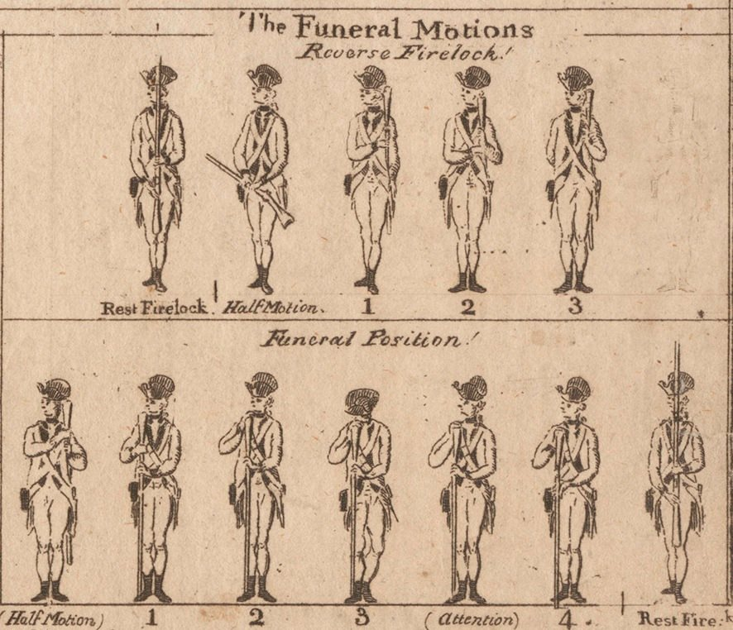
Taken from Gregory Urwin's Post in Facebook Group "Rev War Reenactors" 14/3/15

